Google Search on Optimization algorithms
Optimization algorithms are mathematical procedures designed to find the optimal solution to a problem, typically by minimizing or maximizing a specific objective function. These algorithms are crucial in various fields, including machine learning, operations research, engineering, and data science.
Key Concepts:
- Objective Function:
The function that is to be optimized (minimized or maximized).
- Parameters/Variables:
The inputs to the objective function that the algorithm adjusts to find the optimal solution.
- Iterative Process:
Most optimization algorithms work by iteratively updating the parameters, moving closer to the optimal solution in each step.
- Loss Function (in ML):
A specific type of objective function in machine learning that quantifies the error of a model's predictions.
Types of Optimization Algorithms:
- Gradient-Based Algorithms:
These algorithms use the gradient (first derivative) of the objective function to determine the direction of parameter updates.
  - Gradient Descent (GD): Updates parameters in the direction opposite to the gradient of the loss function.
What is a gradient?
The gradient of a function (like a loss function) at a point is a vector that points in the direction of steepest increase of that function.
For example, if you think of the loss function as a landscape of hills and valleys, the gradient points uphill — the direction in which the function increases most rapidly.

Why move in the negative gradient direction?

Since the gradient points uphill, to minimize the loss, you want to move downhill.
So you move in the direction opposite (negative) of the gradient.
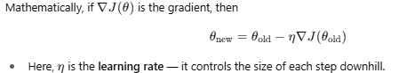
Visual analogy
Imagine you’re standing on a hill and want to get down to the lowest point:
- The gradient tells you which way is uphill.
- To go downhill (reduce your altitude = minimize loss), you take a step opposite to the gradient.
- Repeating this step moves you toward the valley (minimum loss).

  - Stochastic Gradient Descent (SGD): Updates parameters using the gradient of a randomly selected subset (mini-batch) of the data, making it faster for large datasets.
  - Adam, RMSProp, Adagrad: Adaptive learning rate algorithms that adjust the step size for each parameter based on past gradients.
- Derivative-Free Algorithms:
These algorithms do not require the explicit calculation of derivatives.
  - Genetic Algorithms: Inspired by natural selection, they use concepts like mutation and crossover to evolve a population of potential solutions.
  - Simulated Annealing: Inspired by the annealing process in metallurgy, it explores the solution space by accepting worse solutions with a certain probability to escape local optima.
  - Particle Swarm Optimization (PSO): Inspired by the social behavior of bird flocking or fish schooling, it searches for the optimal solution by moving particles through the search space.
Applications:
- Machine Learning: Training models by minimizing loss functions (e.g., in neural networks).
- Operations Research: Optimizing resource allocation, scheduling, and logistics.
- Engineering: Designing optimal structures, systems, and processes.
- Finance: Portfolio optimization and risk management.

Gradient Descent Algorithm:
Manual Working Method
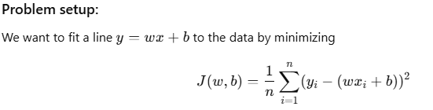
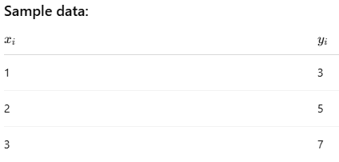
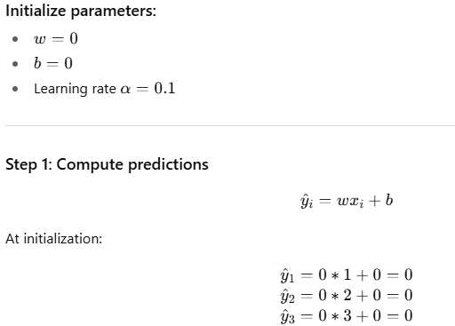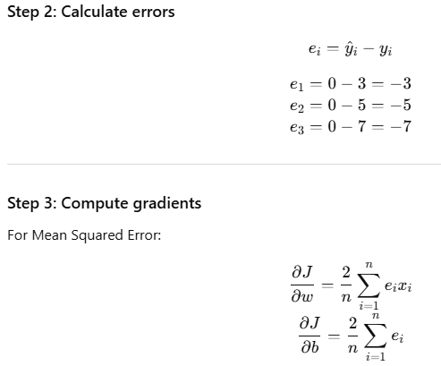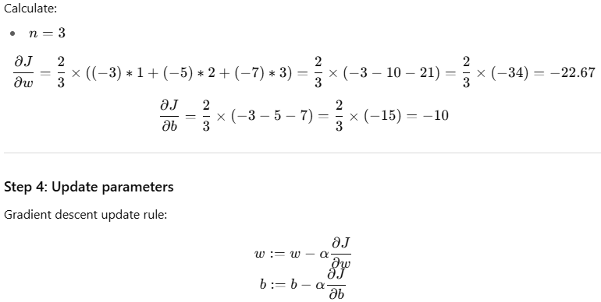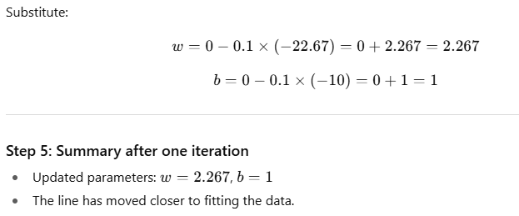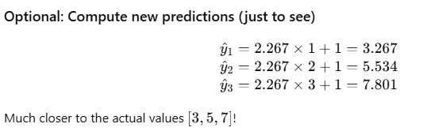

What is Stochastic Gradient Descent?
- Instead of calculating gradients using all data points at once (like batch gradient descent),
- SGD updates the parameters after each individual training example.
- This often leads to faster but noisier convergence.
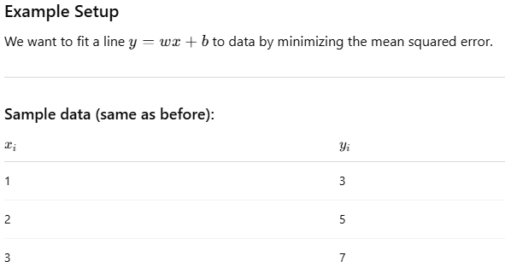
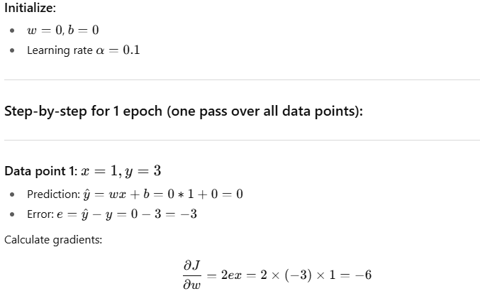
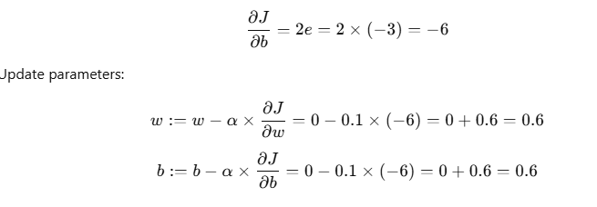
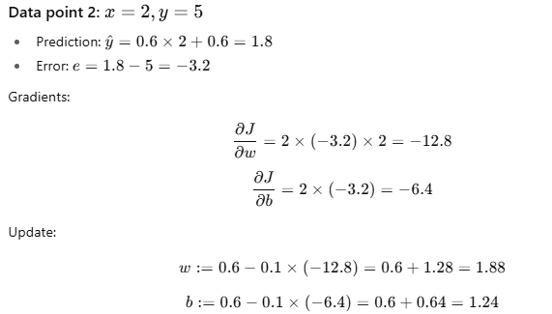
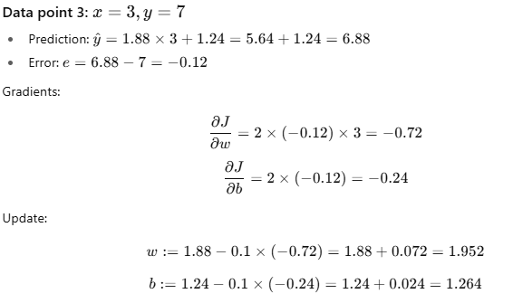
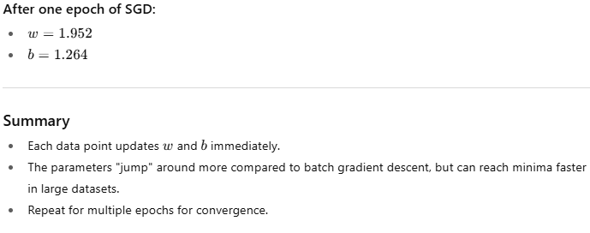

What is Mini-batch Gradient Descent?
- Instead of using all data points (Batch GD) or one data point at a time (SGD),
- Mini-batch GD splits data into small batches (e.g., 2 or 3 samples), computes gradients on each batch, then updates parameters.
- It balances stability and speed, widely used in practice.
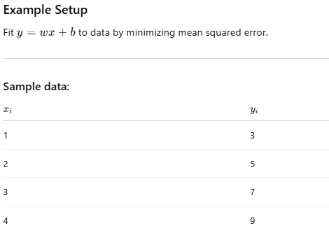
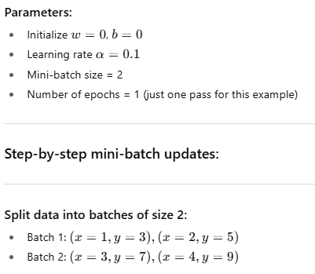
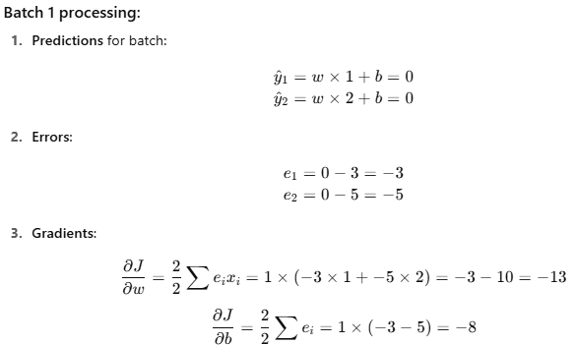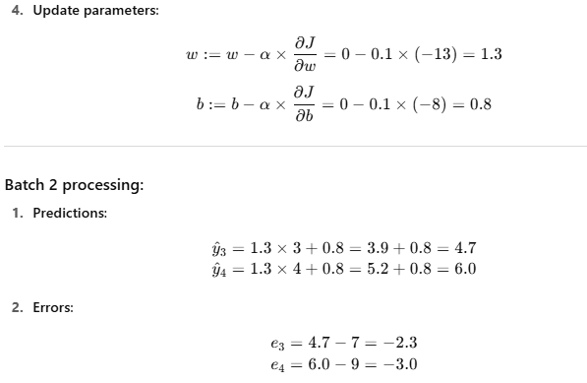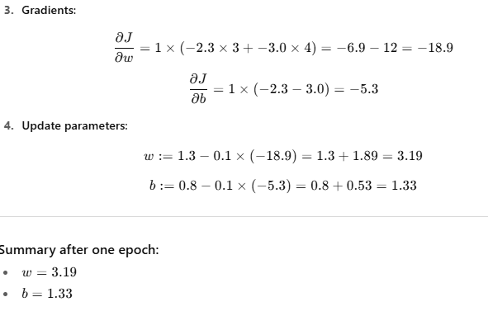
What just happened?
- We updated parameters twice per epoch — once per mini-batch.
- Each batch’s gradients are computed using only the batch’s data points.
- This approach blends the speed of SGD and stability of Batch GD.

Adagrad (Adaptive Gradient Algorithm)
- Idea: Adapt learning rate for each parameter individually based on the history of gradients.
- How: Keeps track of sum of squares of past gradients for each parameter. Parameters with large gradients get smaller updates, parameters with small gradients get larger updates.
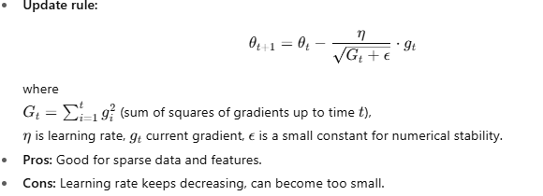
What it does:
Adagrad adapts the learning rate for each parameter individually, shrinking it based on the accumulated squared gradients.

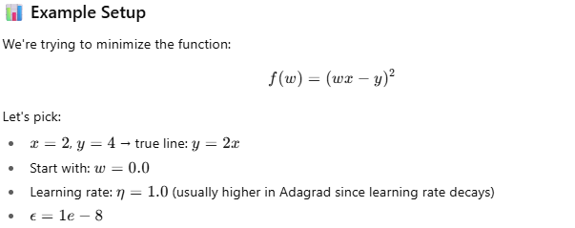
We'll manually compute 2 iterations of Adagrad.
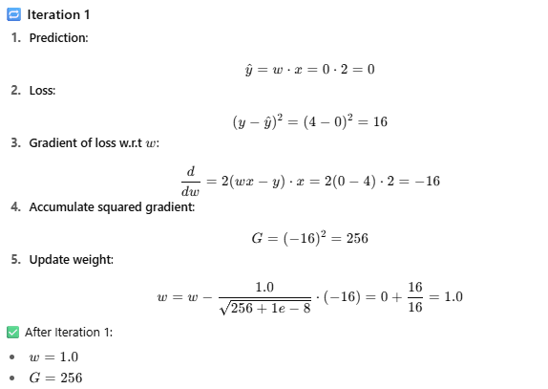
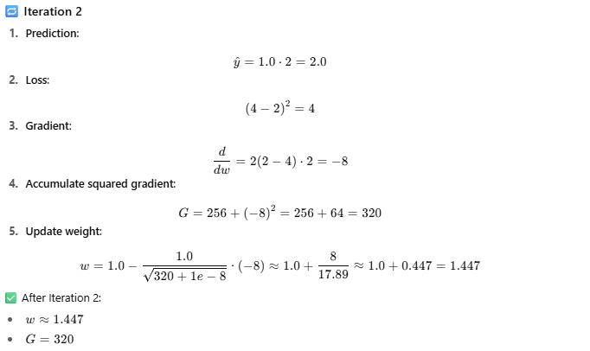

What You Notice:
Learning rate automatically shrinks as gradient history accumulates.
This is especially helpful in sparse features where some parameters rarely update.
In this case, since we have only one parameter, you see it slowing down with each iteration.
Note: I want to know the learning rates after each iteration to confirm that it realy shrinks/decays
RMSProp (Root Mean Square Propagation)
- Idea: Fix Adagrad’s diminishing learning rate problem by using a decaying average of squared gradients instead of sum.
- How: Maintains an exponentially weighted moving average of squared gradients.
What RMSProp Does:
- Instead of accumulating all squared gradients like Adagrad, RMSProp maintains an exponentially decaying average of squared gradients.
- This prevents the learning rate from shrinking too much.

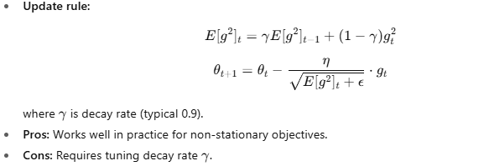

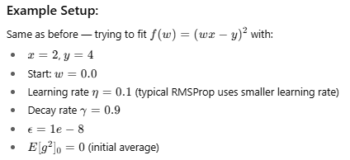
Step-by-step through 2 iterations:
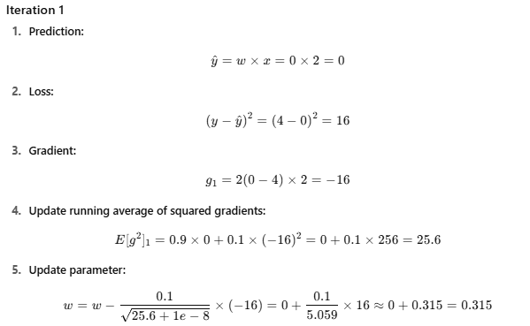

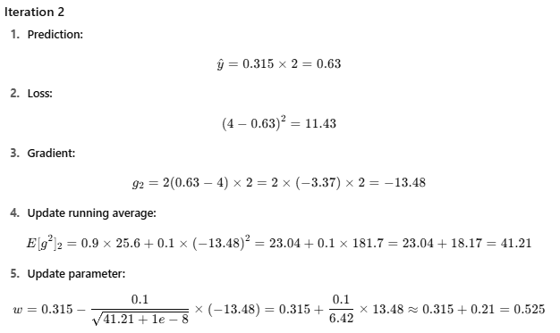

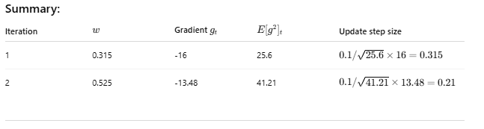

I Observed:
Sum of Squared Gradients in Adagrad => decaying average of squared Gradients on ADAM
Observe the Step Size from Summary…it is shrinking
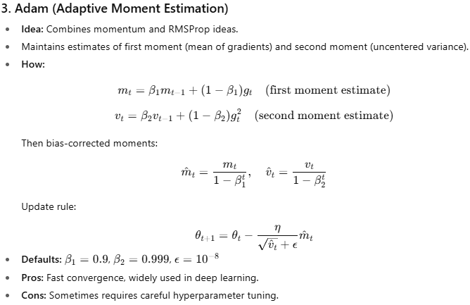
What Adam Does:
Adam combines ideas from Momentum and RMSProp by maintaining:
- First moment estimate mtm_tmt​: Exponentially decaying average of past gradients (like momentum)
- Second moment estimate vtv_tvt​: Exponentially decaying average of past squared gradients (like RMSProp)
It also includes bias correction for both moments to counteract their initial zero values.
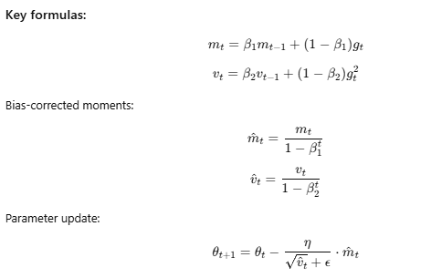
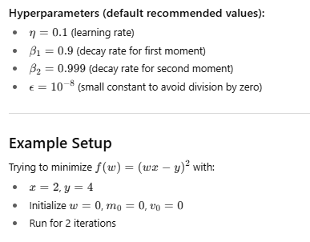
Step-by-step for 2 iterations
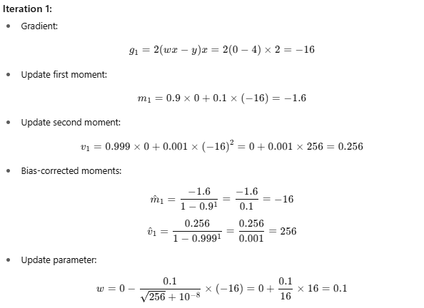
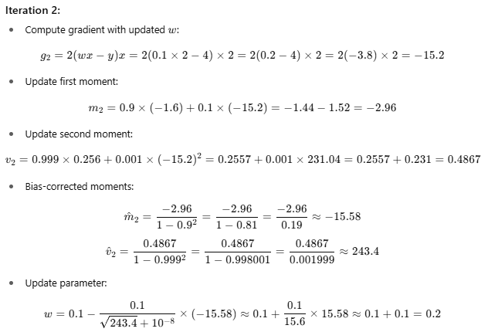

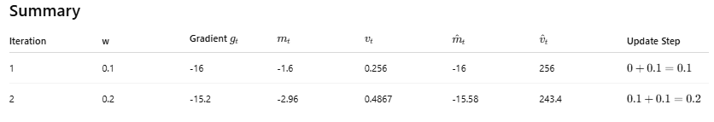

Derivative-Free Algorithms:
What are Derivative-Free Algorithms?
- These optimization algorithms don’t require gradient information (no derivatives needed).
- Useful for non-differentiable, noisy, or complex problems where calculating derivatives is hard or impossible.
- Examples:
  - Genetic Algorithms,
  - Nelder-Mead,
  - Simulated Annealing,
  - Particle Swarm Optimization.

What is a Genetic Algorithm (GA)?
- GA is a biologically inspired optimization algorithm based on natural selection and genetics.
- It mimics how populations evolve over generations by:
  - Selection (choosing best candidates)
  - Crossover (recombining candidates)
  - Mutation (randomly tweaking candidates)
- It works with a population of solutions, evolving them to find the best solution.

Basic GA Workflow:
- Initialize a population of candidate solutions (often randomly).
- Evaluate fitness (objective function value) of each candidate.
- Select the fittest individuals for reproduction.
- Crossover pairs to create offspring.
- Mutate offspring randomly.
- Replace old population with new one.
- Repeat until stopping criteria (max generations or satisfactory fitness).

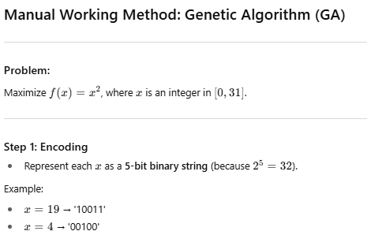
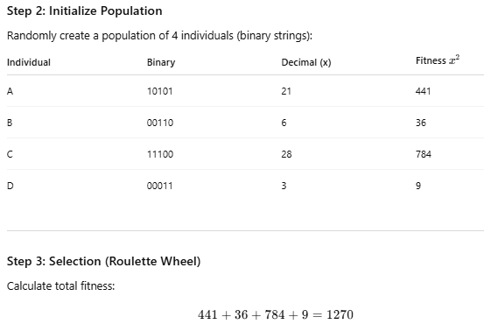
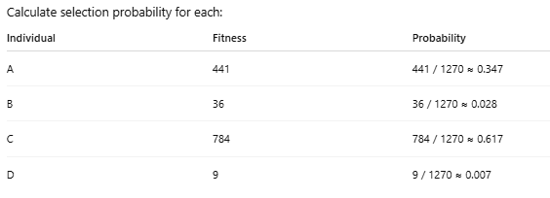
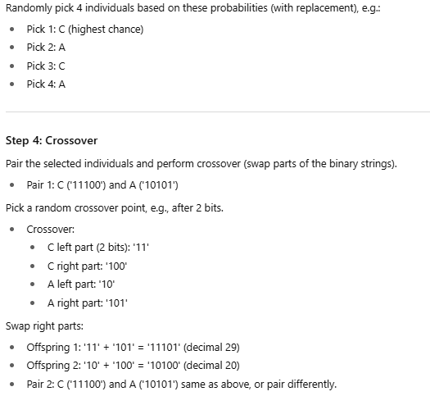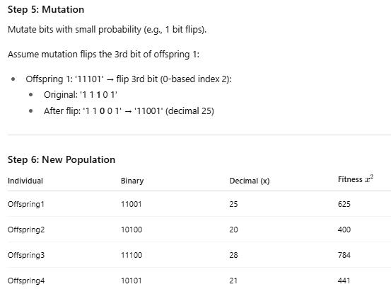
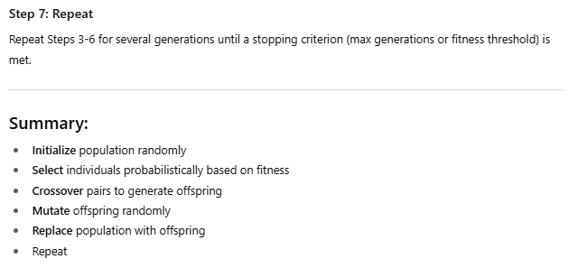

Nelder-Mead Algorithm
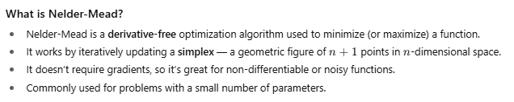
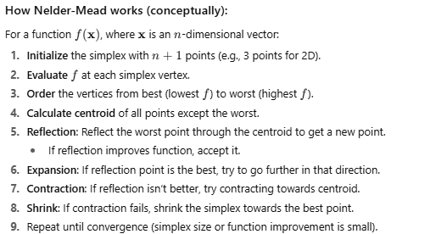
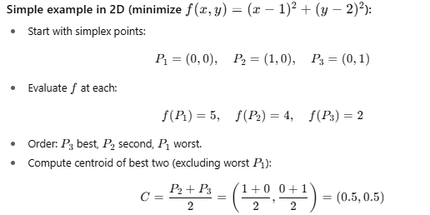
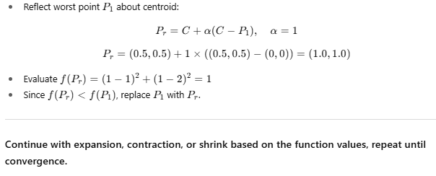
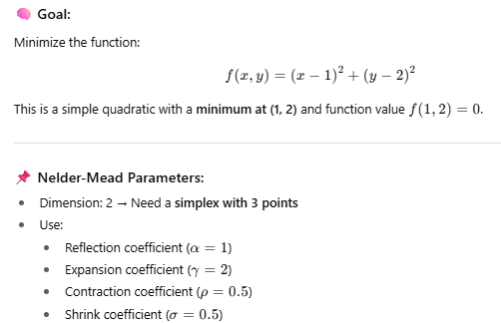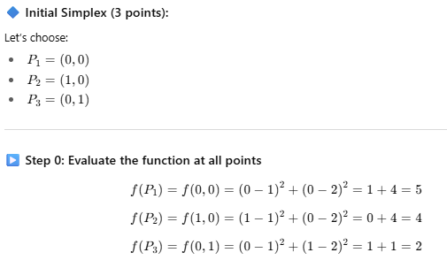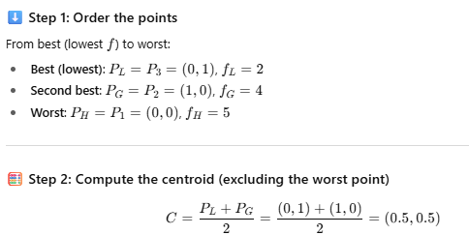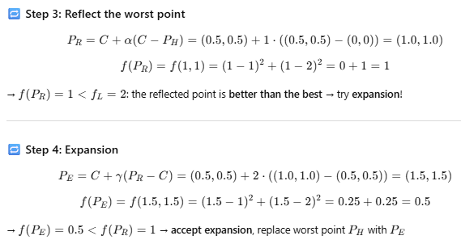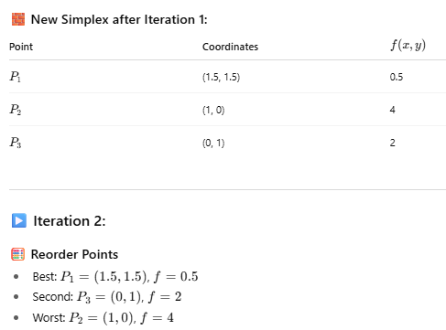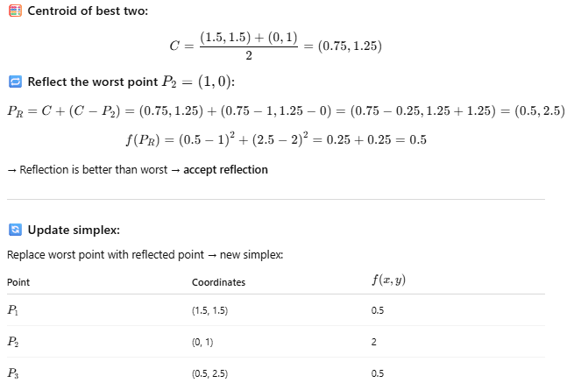
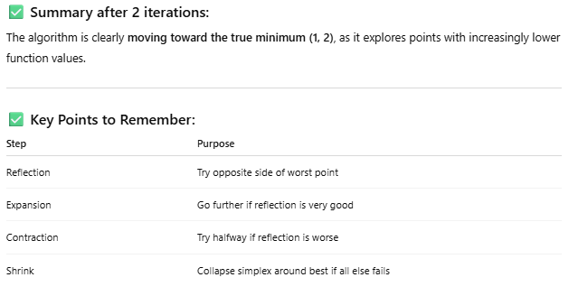
Simulated Annealing
Simulated Annealing is a probabilistic algorithm that searches for a global minimum by allowing both uphill and downhill moves — especially in early stages — to escape local minima.
It mimics the annealing process in metallurgy: slowly cooling a material to reduce defects and reach a low-energy crystalline state.
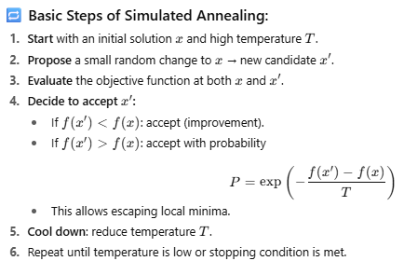

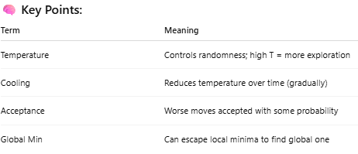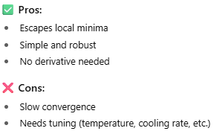
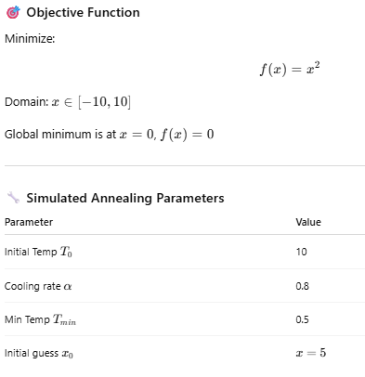
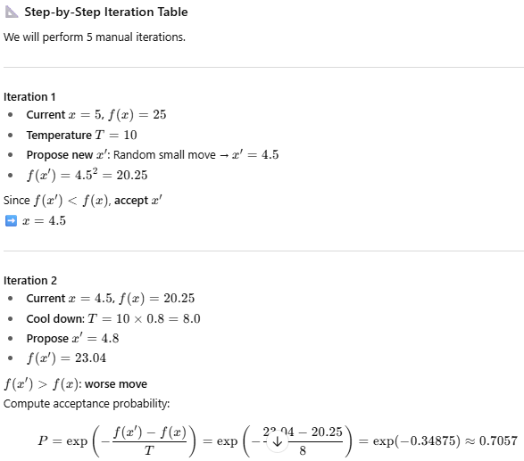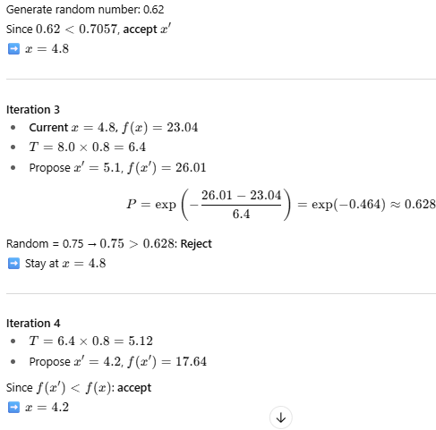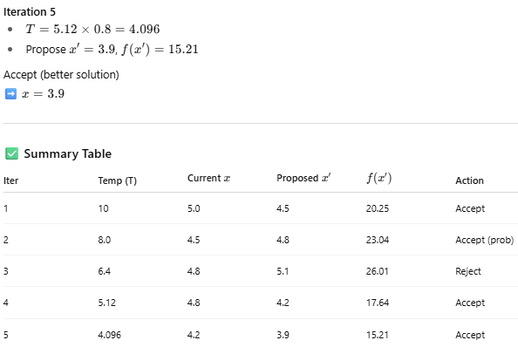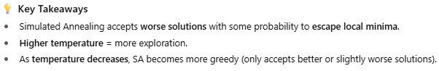
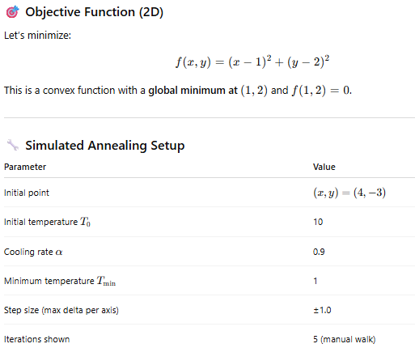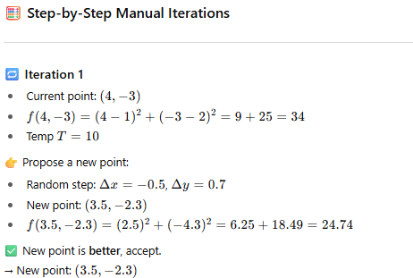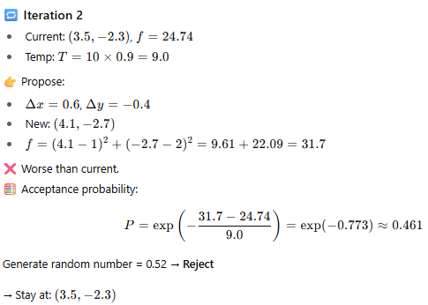
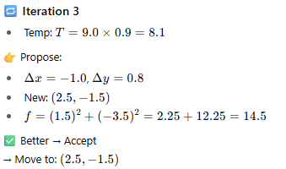
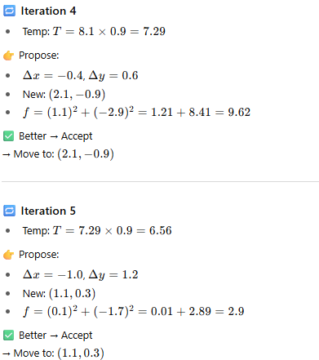
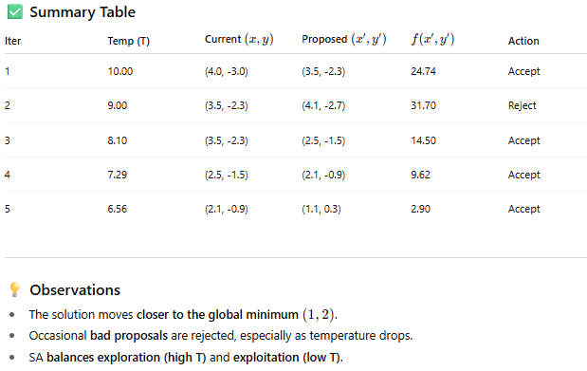
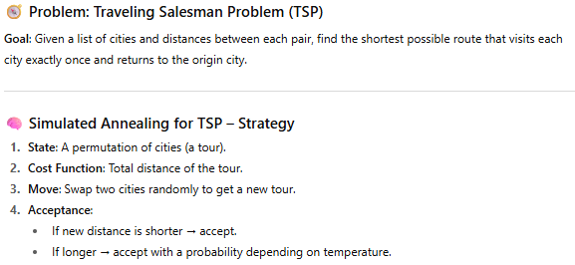

Particle Swarm Optimization (PSO)?
PSO is a population-based optimization algorithm inspired by the social behavior of birds flocking or fish schooling.
- Each solution is a particle in the search space.
- Particles fly through the space, adjusting their position based on:
  - Their own best-known position (personal best),
  - The best-known position of the entire swarm (global best).
- Particles update their velocity and position at each iteration.

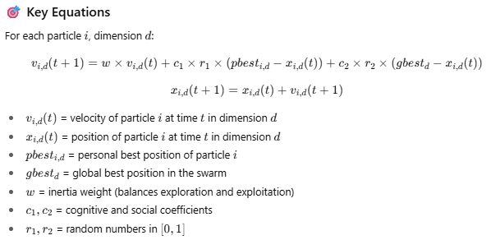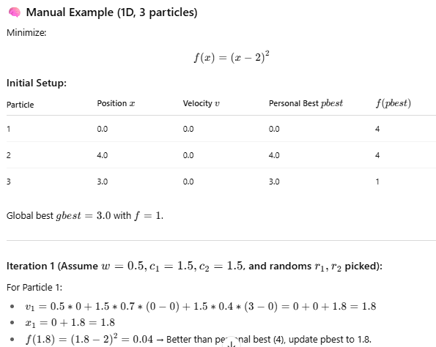
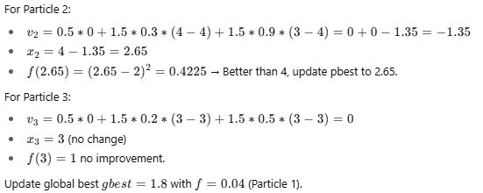

Explain how inertia weight, cognitive/social coefficients affect convergence?
